1. Print in reverse order: You are asked to design a method in linked list to print data in reverse   
order. You don’t need to reverse linked list permanently.

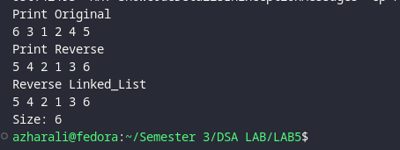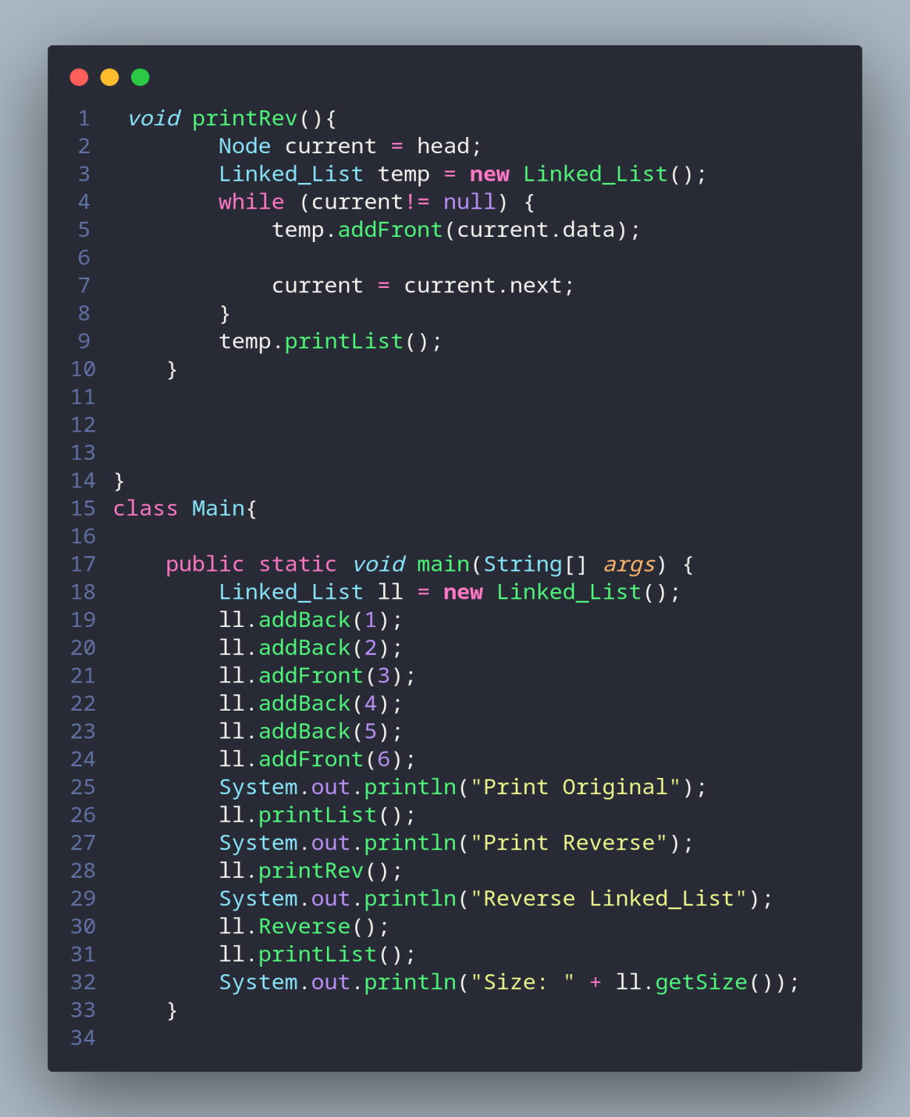

2. Balanced Brackets: Take user string input and check whether it’s balanced or not. Use stack   
functions. Input may contain any of the bracket among {, [, ( and any number and letters like:   
({[a+b]+c}-1) and so on.

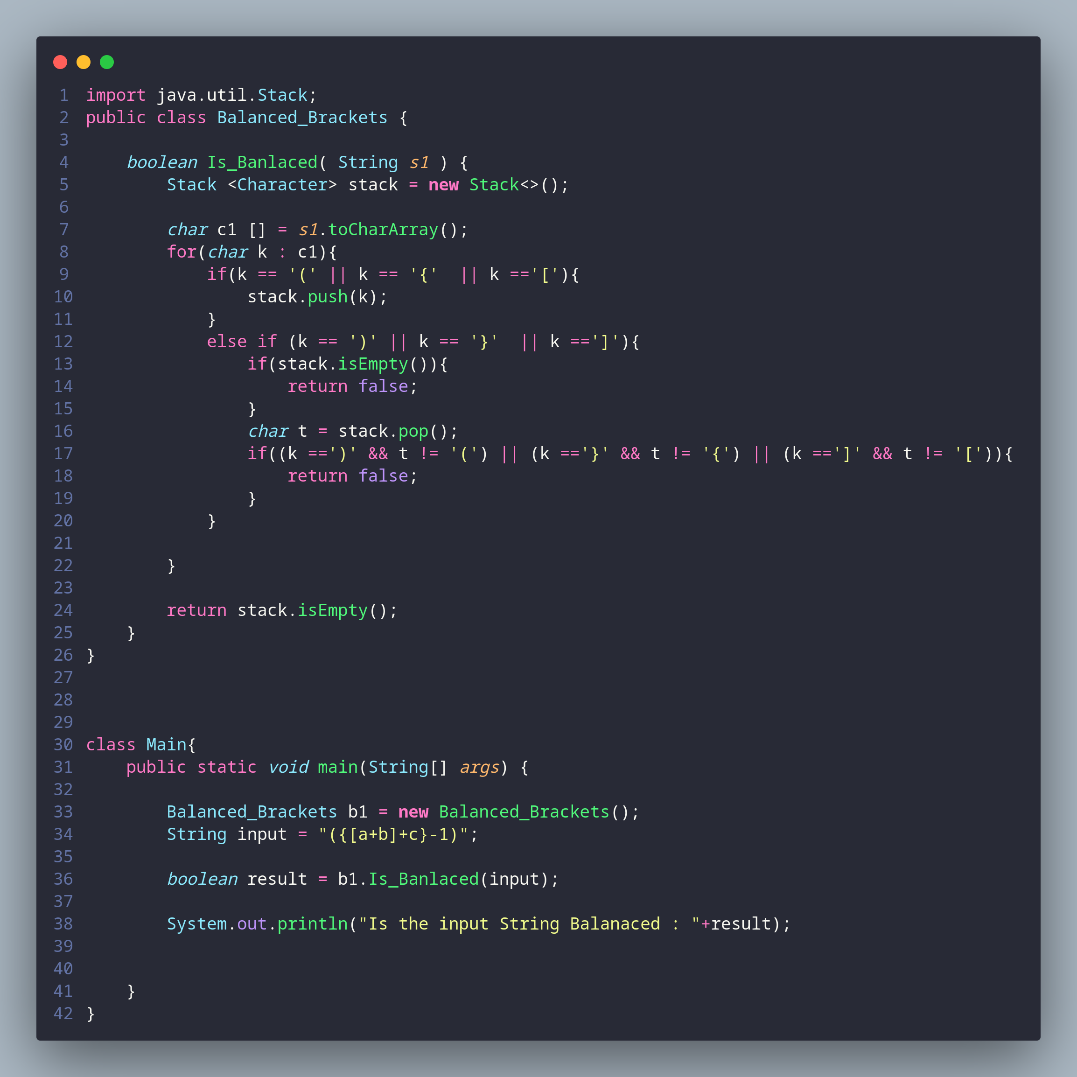

**Task 2**

3. FirstSingleLetter: Create the function char firstSingleLetter (const char text [], const int n)   
which finds and returns the first letter of text that occurs only once. n is the number of   
characters in the text.

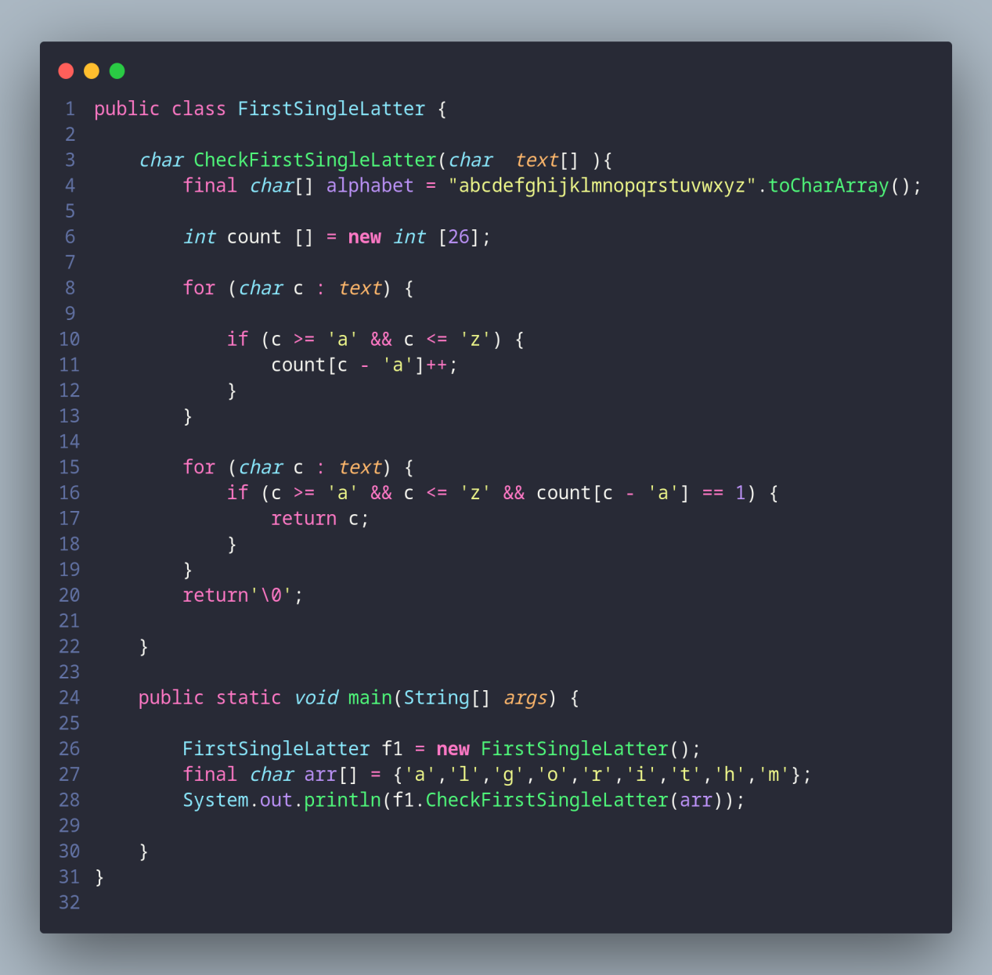

task 3

4. Convert Infix expression to Postfix expression using Stack data structure.   
Input: A + B * C + D Output: ABC*+D+

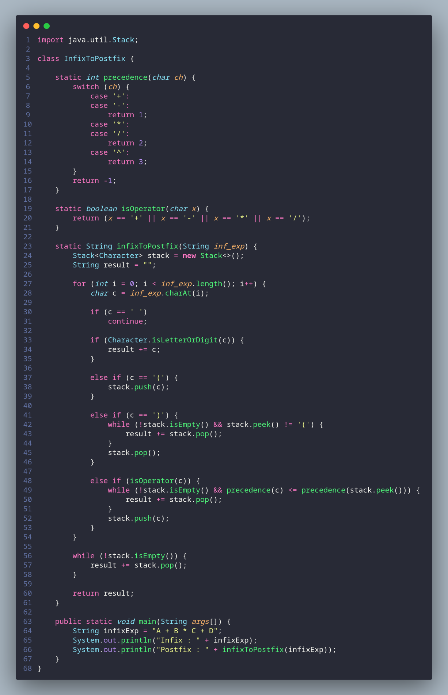

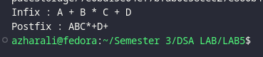

**THE END**